**Parametric Studies of Refrigeration Cycles**

**Advanced Thermodynamics – ME 4571**

Paige Stevenson, Jakob Werle, Christian Gonzalez-Correa

December 12, 2023

Table of Contents

Introduction 2

Problem Analysis 2

System 1: Two Evaporators + Two Compressors + One Flash Tank 2

Part 1: Parametric Solution 2

Part 2: Reference Calculations 3

Part 3: Parametric Study 5

System 2: Two Evaporators + Two Compressors + One Heat Exchanger 8

Part 1: Parametric Solution 8

Part 2: Reference Calculations 9

Part 3: Parametric Study 10

Freezer Temperature vs CoP 10

Refrigerator Temperature vs CoP 11

Ambient Air Temperature vs CoP 12

System 3: Two Evaporators + One Compressor 14

Part 1: Parametric Solution 14

Part 2: Reference Calculations 15

Part 3: Parametric Study 16

Appendix 19

Excel Workbooks: 19

System 1: Hand Solution 19

System 2: Hand Solution 20

System 3: Hand Solution 24

# Introduction

## Problem Analysis

This project aims to design an optimum refrigeration system for a warehouse with freezing and refrigerated spaces. Within this report, various refrigeration systems are investigated, comparing the input power required by the compressor(s) and the coefficient of performance. A parametric study is conducted to investigate the effects of the temperature of the freezer, refrigerator, and ambient temperature have on the coefficient of performance of each system.

There are specific design constraints that each system must adhere to. These constraints are as follows:

* Working Fluid: R-134a
* Freezer temperature range: -24° C< $T_{freezer}$ <-18° C
* Refrigerator Temperature range: 3° C < $T_{refrigerator}$ <7° C
* Ambient Temperature: $T_{0}=25°C$
* Compressor efficiency: 80%
* Temperature difference between the refrigerant and hot and cold reservoir: $∆T=10°C$
* Freezer Cooling load: $Q_{F}=20$ Tons of refrigeration
* Refrigerator Cooling load: $Q_{R}=40$ Tons of refrigeration

# System 1: Two Evaporators + Two Compressors + One Flash Tank

## Part 1: Parametric Solution

System 1 consists of two evaporators, two compressors, and one flash tank. A schematic of the system is displayed in Figure 1: System 1 Diagram below.



Figure : System 1 Diagram

The coefficient of performance for a cycle can be express as

$$COP=\frac{Q_{in}}{W_{in}}$$

Where $Q_{in}$ is the total heat transfer of the system and $W_{in}$ is the total work of the system. In this system, the components that cause work are the two compressors, which can be expressed, in terms of enthalpies, as $W_{compressor}=\dot{m}*∆h$. While the heat transfer comes from the two evaporators. The heat transfer is also expressed by the mass flow rate going through the component times the change in enthalpies, $Q_{evaporator}=\dot{m}*∆h$. Based the schematic of system 1, the coefficient of performance can be rewritten as

$$COP=\frac{{\dot{m}}_{1}\left(h_{1}-h_{8}\right)+{\dot{m}}_{2}\left(h_{3}-h_{6}\right)}{{\dot{m}}_{total}\left(h_{4}-h_{3}\right)+{\dot{m}}_{1}(h_{2}-h_{1})}$$

## Part 2: Reference Calculations

For the initial study of the system, the following parameters were used:

* Freezer temperature, $T_{freezer}=$-18° C
* Refrigerator Temperature, $T_{refrigerator}=$ 4° C
* Ambient Temperature: $T_{0}=25°C$
* Compressor efficiency: 80%
* Temperature difference between the refrigerant and hot and cold reservoir: $∆T=10°C$
* Freezer Cooling load: $Q_{F}=20$ Tons of refrigeration
* Refrigerator Cooling load: $Q_{R}=40$ Tons of refrigeration

Detailed hand calculations are available in the appendix of this report. The T-S and P-H diagrams of the system are shown below.

Figure



Figure

Table 1: System 1 Results below presents a summary of each state's values.

Table : System 1 Results

Table

|  |  |  |  |  |  |
| --- | --- | --- | --- | --- | --- |
| State |  | P(Bar) | $$s\left(\frac{kJ}{kg*K}\right)$$ | $$h\left(\frac{kJ}{kg}\right)$$ | Condition |
| 1 | -28 | 0.9305 | 0.9411 | 230.38 | Saturated Vapor |
| 2s | 4 | 3.3765 | 0.9411 | 256.25 | Superheated |
| 2 | 4 | 3.3765 | 0.9169 | 262.72 | Superheated |
| 3 | 4 | 3.3765 | 0.9169 | 249.53 | Saturated Vapor |
| 4s | 25 | 6.6548 | 0.9169 | 263.73 |  |
| 4 | 25 | 6.6548 | 0.9086 | 267.28 | Superheat |
| 5 | 25 | 6.6548 | 0.3161 | 84.325 | Saturated Liquid |
| 6 | 4 | 3.3765 | - | 84.325 | Mixture |
| 7 | 4 | 3.3765 | - | 55.35 | Saturated Liquid |
| 8 | -18 | 1.4483 | - | 55.35 | Mixture |

The mass flow rate of each part of the system is shown in Table 2.

Table : Mass flow Rate

|  |  |  |
| --- | --- | --- |
| $${\dot{m}}_{1}\left(\frac{kg}{s}\right)$$ | $${\dot{m}}_{2}\left(\frac{kg}{s}\right)$$ | $${\dot{m}}_{total}\left(\frac{kg}{s}\right)$$ |
| $$.4018$$ | $$.8515$$ | $$1.2533$$ |

## Part 3: Parametric Study

Effects of $T_{freezer}$ on COP

In this examination, we will assess the system by modifying the freezer temperature range from -24°C to -18°C, while maintaining the refrigerator temperature at 4°C and the ambient temperature at 25°C. An observable trend emerges as the freezer temperature rises, leading to an increase in the Coefficient of Performance (COP), as illustrated in Figure 4. According to Table 3, the COP ascends from 5.47 at -24°C to 5.99 at -18°C, representing a notable 0.52 improvement over the 6-degree temperature shift. In summary, it is evident that an elevation in freezer temperature correlates with an augmentation in the system's COP.

Table

|  |  |
| --- | --- |
| T_freezer | COP |
| -18 | 5.99 |
| -20 | 5.81 |
| -22 | 5.64 |
| -24 | 5.47 |
|  |  |

Figure

Effects of $T_{Refrigerator}$ on COP

This study delves into the impact of refrigeration temperature on the Coefficient of Performance (COP). Specifically, we manipulate the refrigerator temperature within the range of 4°C to 7°C, while maintaining the freezer temperature at -18°C and the ambient temperature at 25°C. Similar to the freezer, an elevation in refrigerator temperature corresponds to an increase in COP, as depicted in Figure 5. According to the findings presented in Table 3, the COP rises from 5.87 at 3°C to 6.31 at 7°C, representing a noteworthy 0.44 improvement over the 4-degree temperature variation. In summary, it is evident that an increase in refrigerator temperature correlates with an enhancement in the system's COP

Table

|  |  |
| --- | --- |
| T_R | COP |
| 3 | 5.87 |
| 5 | 6.09 |
| 7 | 6.31 |

Figure

Effects of $T_{0}$ on COP

This study focuses on examining the influence of ambient temperature on the system. The ambient temperature undergoes a transition from 25°C to 35°C, while maintaining the refrigerator temperature at 4°C and the freezer temperature at -18°C. Notably, as the ambient temperature rises, there is a corresponding decrease in the Coefficient of Performance (COP), as depicted in Figure 6.

As outlined in Table 4, the COP decreases from 6.13 at 24°C to 5.07 at 35°C, signifying a substantial 1.06 reduction over the 11-degree temperature shift. Despite the ambient temperature variation, the heat transfer of the evaporators remains constant. However, there is an increase in the power input required for compressors. Consequently, it is evident that an escalation in ambient temperature is associated with a decline in the system's COP.

Table

|  |  |
| --- | --- |
| T_0 | COP |
| 24 | 6.13 |
| 26 | 5.85 |
| 28 | 5.58 |
| 30 | 5.32 |
| 32 | 5.07 |

Figure

Summary of Parametric Study

When the freezer temperature is raised from -24°C to -18°C, with the refrigerator and ambient temperatures held constant at 4°C and 25°C respectively, the COP of the system experiences an increase. Similarly, an increase in refrigerator temperature from 4°C to 7°C, with the freezer and ambient temperatures held constant at -18°C and 25°C, results in an increased COP for the system. In contrast, elevating the ambient temperature from 25°C to 35°C, with the refrigerator and freezer temperatures held constant at 4°C and -18°C, leads to a decrease in the COP of the system.

# System 2: Two Evaporators + Two Compressors + One Heat Exchanger

## Part 1: Parametric Solution

The second refrigeration and freezer system was designed with two evaporators, two compressors, and one heat exchanger. The schematic for this refrigeration cycle is shown below.

Figure Refrigeration Cycle 2

To determine the coefficient of performance (CoP), the energy transfer throughout the system must be calculated. It depicts where heat will be extracted and rejected as well as where work is input. CoP can be defined as:

$$CoP=\frac{\dot{Q_{in}}}{\dot{W_{in}}}$$

Where Q_in is the heat extracted from the fridge and freezer space by each evaporator, and W_in is the work required by each compressor to run the system.

The energy transferred in each component can be solved using the energy balance equation:

$$\dot{Q_{cv}}+\dot{m_{i}}h_{i}=\dot{m_{e}}h_{e}+\dot{W_{cv}}$$

For each component, the energy balance equations turn into:

|  |  |
| --- | --- |
| Evaporator 1 (Freezer) | $$\dot{Q_{F}}=\dot{m_{F}}{(h}_{1}-h_{7})$$ |
| Evaporator 2 (Refrigerator) | $$\dot{Q_{R}}=\dot{m_{R}}{(h}_{8}-h_{6})$$ |
| Compressor 1 | $$\dot{W_{C1}}={\dot{m}}_{F}{(h}_{2}-h_{1})$$ |
| Compressor 2 | $$\dot{W_{C2}}=\dot{{\dot{m}}_{total}}{(h}_{4}-h_{3})$$ |

The CoP can then be evaluated as:

$$CoP=\frac{\dot{Q_{F}}\dot{+ Q_{R}}}{\dot{W_{C1}+W_{C2}}}=\frac{\dot{m_{F}}{(h}_{1}-h_{7})+\dot{m_{R}}{(h}_{8}-h_{6})}{{\dot{m}}_{F}{(h}_{2}-h_{1})+\dot{{\dot{m}}_{total}}{(h}_{4}-h_{3})}$$

## Part 2: Reference Calculations

The following parameters were used to solve a sample hand calculation.



Figure Temperatures for Hand Solution

Knowing these parameters along with the condition of the working fluid, R-134A, for each state, the enthalpy, mass flowrate, and other related properties can be solved for as shown below. As shown above, the coefficient of performance is dependent on the enthalpy and mass flow rate for each state.



Figure R-134A Properties at Each State

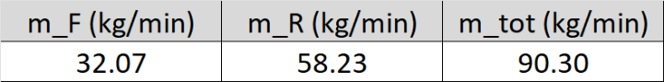

Figure Resulting Mass Flowrates

Finally, the coefficient of performance is calculated using the above values. Detailed calculations can be found in the appendix.



Figure Resulting Coefficient of Performance

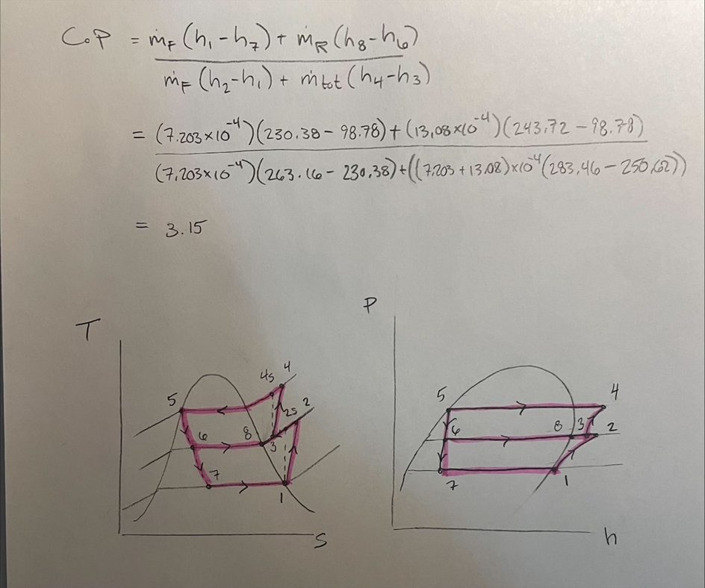

Figure T-S and P-h Diagrams

Figure 12 displays the T-S and P-h diagrams for the designed cycle.

## Part 3: Parametric Study

To evaluate the impact of each heat reservoir’s temperature on the system, a sensitivity analysis was performed. In particular, the coefficient of performance was compared to a set of temperatures for the freezer, refrigerator, and ambient air spaces.

### Freezer Temperature vs CoP

For the first analysis, the temperature of the freezer space varied from -24°C to -18°C. The refrigerator and ambient air temperatures were held at their minimum temperatures of 3°C and 25°C, respectively.

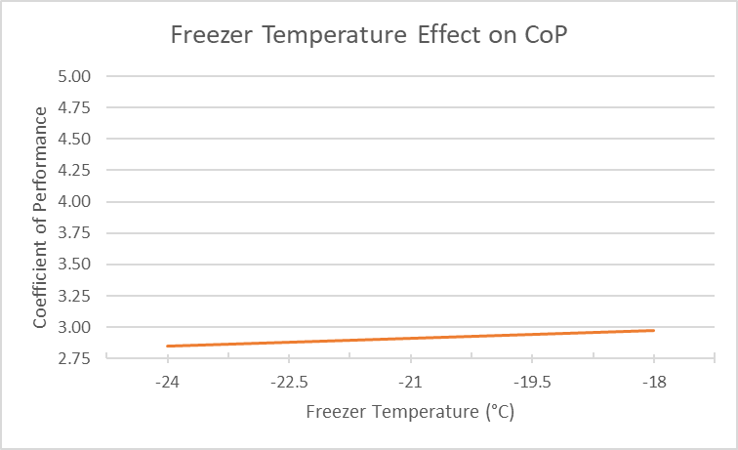

Figure Freezer Temp vs CoP Graph

The plot in Figure 12 shows that increasing the temperature of the freezer space also increases the coefficient of performance. Changing freezer temperature affects the fluid properties at states 1, 2, 3, and 4 which increase enthalpy at states 1 and 2. Since the heat extracted by the evaporator from the freezer space is dependent on change in enthalpy between states 1 and 7, the overall Q_in increases. This subsequently increases the coefficient of performance which is defined by ratio of Q_in over W_in. Functionally speaking, it is easier for the freezer system to maintain a cooling temperature that is warmer and closer to ambient temperature. This change increases CoP roughly 0.02 per degree C.

### Refrigerator Temperature vs CoP

The next analysis sets the freezer and ambient air temperatures to their lowest values of -24°C and 25°C, respectively. The refrigerator temperature varied from 3°C to 7°C to analyze its effect on coefficient of performance.

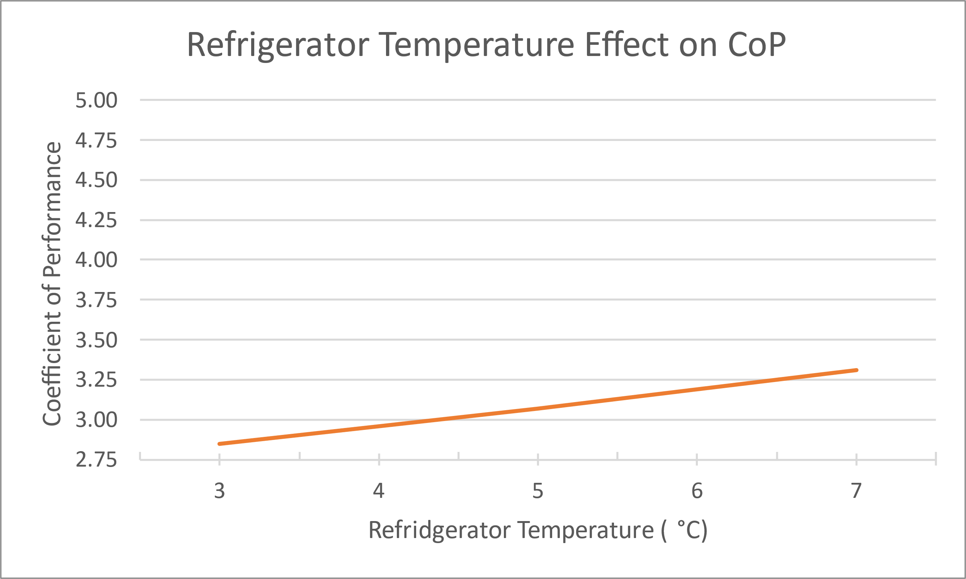

Figure Refrigerator Temp vs CoP Graph

In Figure 13, the graph shows the change in coefficient of performance as the refrigerator temperature is increased. Changing the refrigerator temperature had effects on fluid properties at states 2, 3, 4, and 8. Enthalpy increased at each one of these states due to increases in pressure and mass flow rate across the system. It is clear that the refrigerator temperature has a larger impact on the performance of the system. This is largely due to the mass flow rate through the refrigerator side being about twice as high as the freezer. This adjustment results in an increase in CoP of about 0.114 per degree C. Similar to the freezer, this change makes functional sense since it takes less energy to maintain a space at a higher temperature.

### Ambient Air Temperature vs CoP

Finally, the coefficient of performance was analyzed as the ambient air temperature varied from 25°C to 30°C. For this study, the freezer and refrigerator temperatures were kept at their lowest values of -24°C and 3°C.

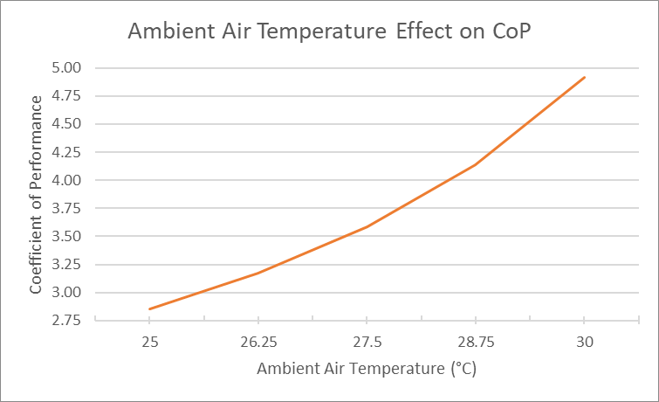

Figure Ambient Air Temp vs CoP Graph

The graph in Figure 14 shows how the increase in ambient air temperature affects coefficient of performance. According to the analysis, increasing ambient air temperature has a significant impact, raising the CoP from ~2.8 to almost 5.0. The adjustment in temperature changed property values at states 3,4,5,6, and 7. The most significant changes were in enthalpy at states 4, 5, 6, and 7. The calculated effect on CoP is roughly 0.40 per degree C. The results of this analysis do not align with what would likely happen in a real-life system. As ambient air increases in temperature, the difference in temperature between it and the condenser decreases, effectively decreasing the ability for heat rejection. This hypothesis conflicts with the results of this study which suggests a calculation error.

# System 3: Two Evaporators + One Compressor

## Part 1: Parametric Solution

Figure : System 3 schematic

A schematic of the system is shown above, including work and heat transfers at each device. To find the coefficient of performance of the system, we must define each energy transfer in the system. The steps taken to solve the COP of the system are listed below.

First, the mass and energy balance equations are used to solve the heat and work transfer at each device in the system. These equations are shown below for reference.

$$\dot{m}=\dot{m_{R} }+\dot{m_{F}}$$

$$\dot{Q_{cv}}+\dot{m_{i}}*h_{i}=\dot{m_{e}}*h_{e}+\dot{W_{cv}}$$

The equations for heat and work transfer to and from the system at the refrigerator, freezer, condenser, and compressor are as follows:

$$\dot{Q_{{in}_{R}}}=\dot{m_{R}}{(h}_{5}-h_{4})$$

$$\dot{Q_{{in}_{F}}}=\dot{m_{F}}{(h}_{8}-h_{7})$$

$$\dot{Q_{out}}=\dot{Q_{c}}=\dot{m}{(h}_{2}-h_{3})$$

$$\dot{W_{in}}=\dot{W_{c}}=\dot{m}{(h}_{2}-h_{1})$$

The ratio of total heat entering the system and work entering the system defines our coefficient of performance for the entire system.

$$COP=\frac{\dot{Q_{in}}}{\dot{W_{in}}}=\frac{\dot{Q_{{in}_{R}}}\dot{+ Q_{{in}_{F}}}}{\dot{W_{c}}}=\frac{\dot{m_{R}}{(h}_{5}-h_{4})+ \dot{m_{F}}{(h}_{8}-h_{7})}{\dot{m}{(h}_{2}-h_{1})}$$

## Part 2: Reference Calculations

After choosing the operating temperatures for the refrigerator and freezer to fit within the project requirements, we can use the thermodynamic tables for R-134a to solve the desired variables above.



Figure : Chosen temperatures of each evaporator

Knowing that the compressor efficiency is 80%, we can relate equations to find the enthalpies at states 2 and 2s. These values can be used to find the work entering the compressor and essentially the COP. All essential values at each state are found and listed in the table below.



Figure : Solved variables at each state



Figure : Solutions for mass flow rates and energy transfers



Figure : Solved COP

A plotted graph alongside a sketch of a P-H diagram is shown below for the system.

A plotted graph alongside a sketch of a T-S diagram for the system is shown below for the system.

## 

## Part 3: Parametric Study

To determine which parameters of the system directly affect the coefficient of performance, we run a study varying each temperature of the system. First, we will vary the freezer temperature.



Figure : Freezer temperature study results

Figure : COP vs. T, Freezer

The results of this study conclude that increasing the temperature of the freezer in the system will decrease the coefficient of performance. This is shown in the table and graph plotted above.

Next, we will vary the temperature of the refrigerator to see the effects on the coefficient of performance of the system. The results are shown below.



Figure : Refrigerator temperature study results

Figure : COP vs. T, Refrigerator

The results of this study conclude that increasing the temperature of the refrigerator in the system will not affect the coefficient of performance. This is shown in the table and graph plotted above with a constant slope of COP.

Finally, we will vary the ambient temperature to see the effects on the coefficient of performance of the system. The results are shown below.



Figure : Ambient temperature study results

Figure : COP vs. T, Ambient

The results of this study conclude that increasing the ambient temperature in the system will decrease the coefficient of performance. This is shown in the table and graph plotted above.

# Appendix

## Excel Workbooks:

System 1 - [System 3.xlsx](https://tuprd-my.sharepoint.com/:x:/r/personal/tun83819_temple_edu/Documents/System%203.xlsx?d=wcc1eee365f4141599609e5fed475c329&csf=1&web=1&e=jKTY9e)

System 2 - [Thermo](https://tuprd-my.sharepoint.com/personal/tuj61118_temple_edu/Documents/Thermo.xlsx?web=1)

System 3 - [System 3 Excel](https://tuprd.sharepoint.com/:x:/r/sites/TU23FL-Adv_Thermo-Final_Project/Shared%20Documents/General/TU23FL-adv_thermo-final_project.xlsx?d=w0d0bbc1e9aad46a1bbadf401a2a520fd&csf=1&web=1&e=xcaBc4)

## System 1: Hand Solution

## System 2: Hand Solution

## System 3: Hand Solution

